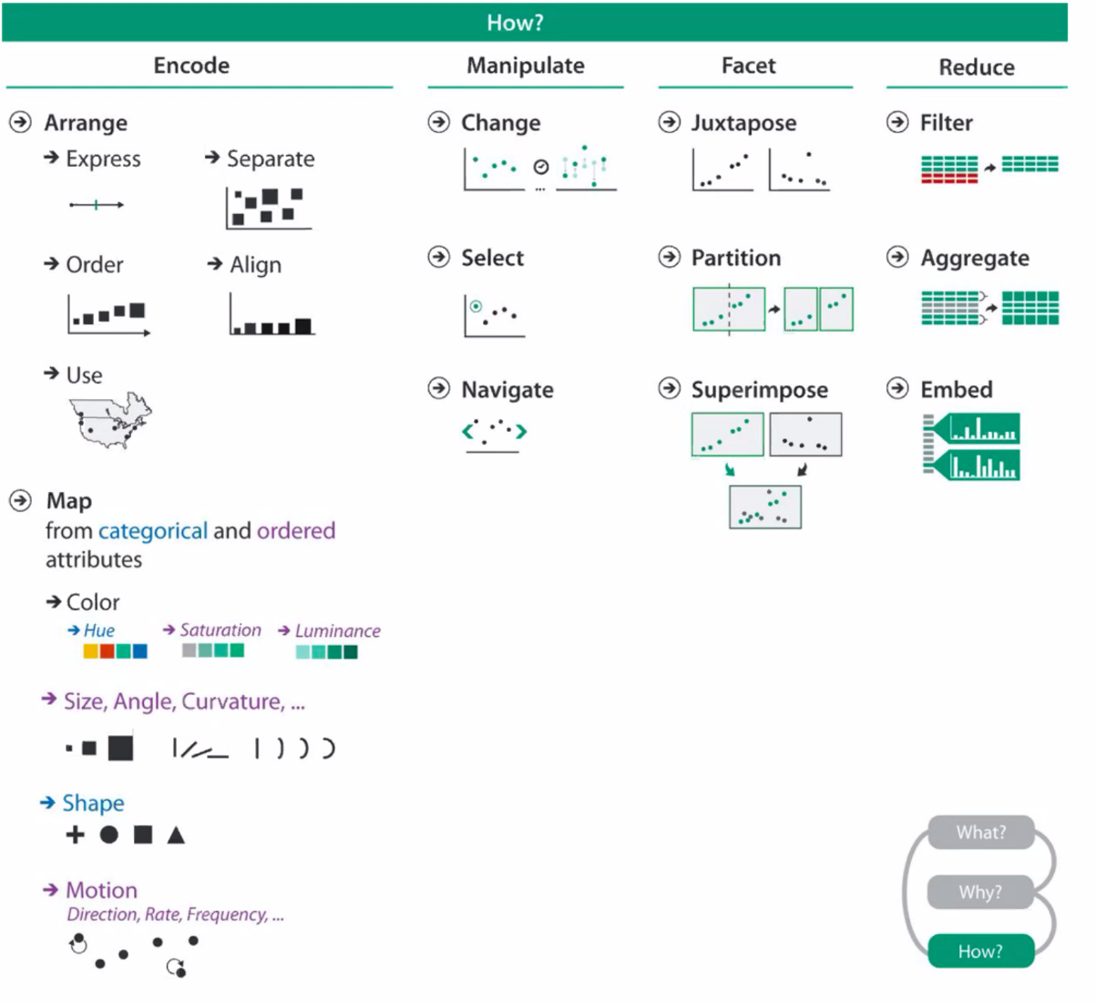

Marks

* Basic graphical element visualized as geometric primitive
* Dimensions
  + 0D: Points
  + 1D: Lines
  + 2D: Areas

Channels:

* Position
* Color
* Shape
* Tilt
* Size
  + Length
  + Area
  + 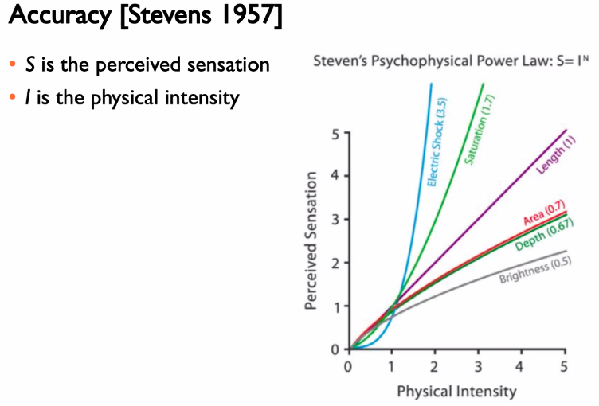Volume
* Use
  + Effectiveness principle
    - Importance of attribute should match salience of channel
  + Expressiveness principle
    - Visual encoding should express all of and only information in the dataset attributes